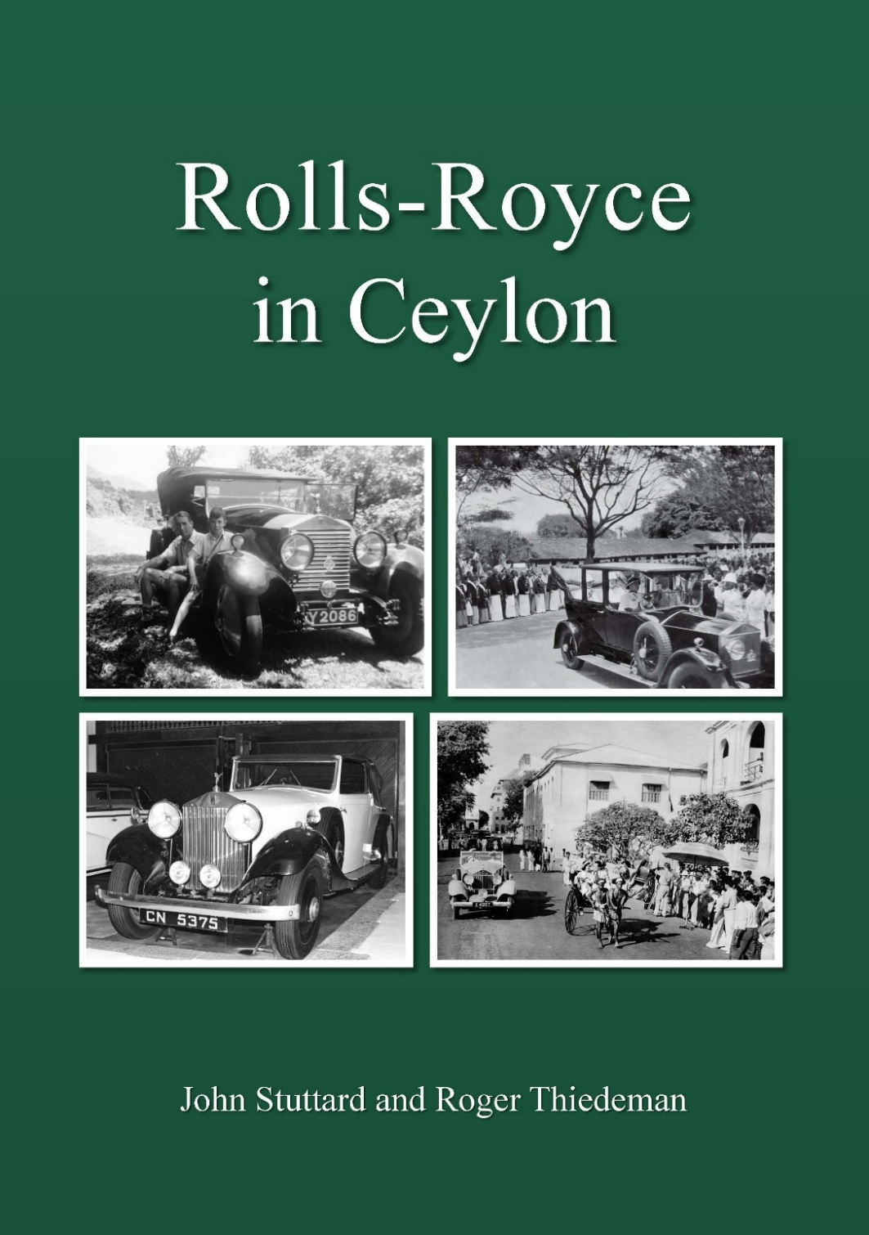

The tropical island of Ceylon, renamed Sri Lanka in 1972, has been romantically known as the Pearl in the Indian Ocean and the Emerald Isle, due to its location and the island’s lush, green landscapes, particularly its rice paddies and extensive tea plantations. For more than a century it was a Portuguese colony, then Dutch and in 1802 it became part of the British Empire. Tea was introduced in the middle of the 19th century and grew to being a key agricultural industry. Lipton’s and Brooke Bond developed as well-known brands. In the other direction came goods manufactured in Great Britain. The names of Austin, Humber, Morris, Wolseley and even Rolls-Royce were represented amongst cars available for purchase. The importers of Rolls-Royce models were tea planters. But they were also wealthy Ceylonese landowners who had estates with many including coconut plantations. From coconut a strong alcoholic beverage known as arrack, from which toddy was also made, yielded large financial returns for these ‘arrack renters’ who owned licensed premises which they rented to local retailers. Rolls-Royce Limousines of suitable stature were also acquired for Governor-Generals and, later, for Prime Ministers. This book, which will printed and available for distribution in early January 2026, describes 29 Rolls-Royce motor cars which had some connection with Ceylon. With almost 400 illustrations covering almost 200 pages, the book is a collector’s item of academic quality and great historical interest.
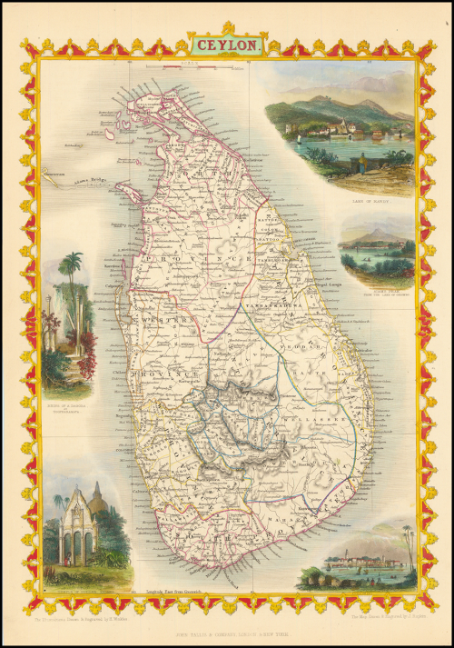
The book begins with an illustrated history of Ceylon as an entrée into the country and a description of the people who acquired the 29 cars and then of the cars themselves. It is as much an attractive coffee table book as an academic work, being a definitive account of these Rolls-Royce motor cars with a connection with Ceylon.

Prompted by the well-known author, Tom Clarke, club members Sir John Stuttard and Roger Thiedeman, Ceylon-born Australian, have produced a descriptive and illustrated record. The book will be published, and copies despatched by The 20-Ghost Club in January 2026. Copies can be ordered through the club, with net sales proceeds accruing to The Sir Henry Royce Memorial Foundation, a charity which is the custodian of the original Rolls-Royce records. The book will be priced at £35 per copy plus postage. Postage rates will vary depending on destination.

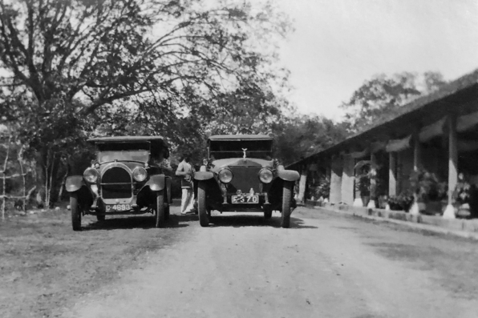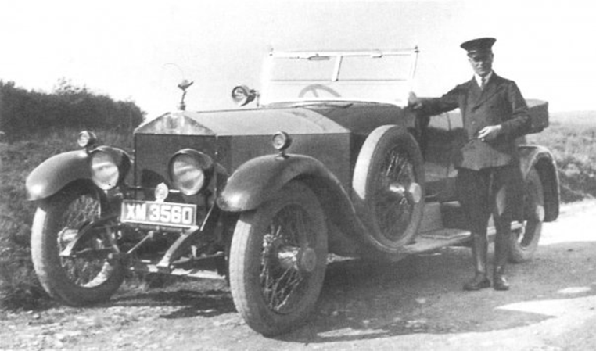

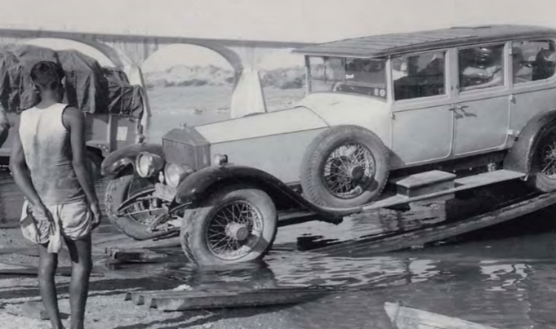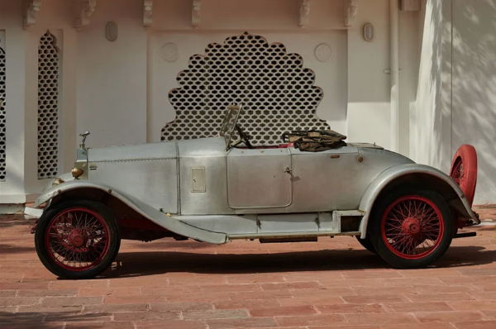

Copies of Rolls-Royce in Ceylon can be ordered by emailing johnstuttard@btinternet.com – giving your name and postal address - with funds simultaneously paid to the club via one of the club’s banks shown below. If you’re paying from outside the UK, eg from the USA or Ceylon, you can also use PayPal (but please add £2.50 for the charge they make): 20ghostpay@gmail.com, with email to Steve Wilks, 20-Ghost Club Treasurer (rslwilks@gmail.com).

For Sterling:  Bank – Lloyds;  Sort code: 30-96-35  Branch: CARFAX OXFORD  BIC: LOYDGB21023  IBAN: GB69 LOYD 3096 3500 0668 03  Account name: The 20-Ghost Club Limited  Account no: 00066803 | For Euros:  Bank - C Hoare & Co  37 Fleet Street, London EC4P 4DQ  Account Name: The 20-Ghost Club Ltd  Sort Code: 15-99-00  Account No: 27487380  IBAN: GB88 HOAB 1599 0027 4873 80  BIC: HOABGB2L
Prices (including postage) vary according to destination: UK: £40; Europe: €60; US: $65; Sri Lanka: £60; ROW: £65. Please e-mail Steve Wilks (rslwilks@gmail.com) and John Stuttard (johnstuttard@btinternet.com) when you have transferred funds.

